Issues Identified:
- Request Timeouts: In the Analytics tab, we are frequently seeing a "Timeout: Request failed to complete in 120000ms" error. This is likely due to the server-side rollups taking too long for the selected date range.
- 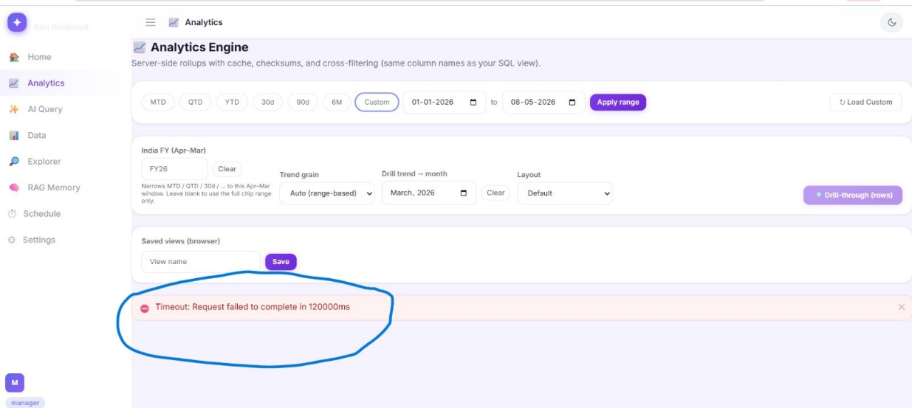

- Checksum Failure: The Checksum (Σ) tile is currently showing a null/dash value (—). It isn't validating the data against the source, which is critical for our financial reporting.
- 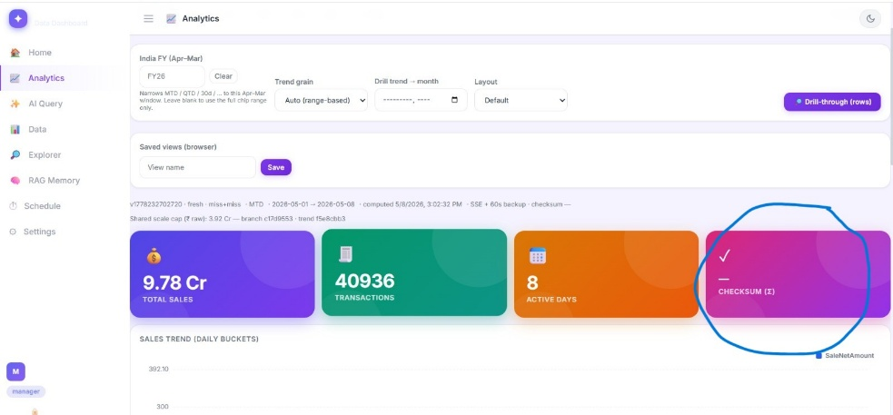
- X-Axis Label Redundancy: On the "Sales — Chart" (Line view), the X-axis is repeating the same date (08-05-2026) multiple times instead of showing a chronological sequence or specific timestamps.
- 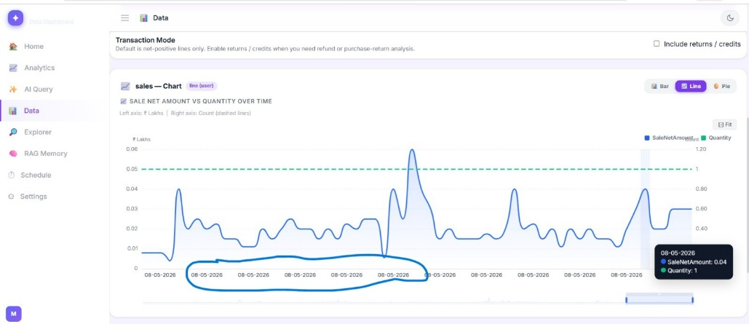

- Data Scaling Discrepancy: On the Bar Chart, the tooltips show a SaleNetAmount of 0.02 for a quantity of 1, but the "Total Sales" on the main overview shows 9.78 Cr. There seems to be a disconnect between the unit of measurement (Lakhs vs. Crores) and how the individual data points are being aggregated.

- Timestamp Formatting: The labels on the Bar Chart are showing raw ISO strings (e.g., 2026-05-08T00:00:00.000Z). These should be formatted to a more readable Date/Time format.

- 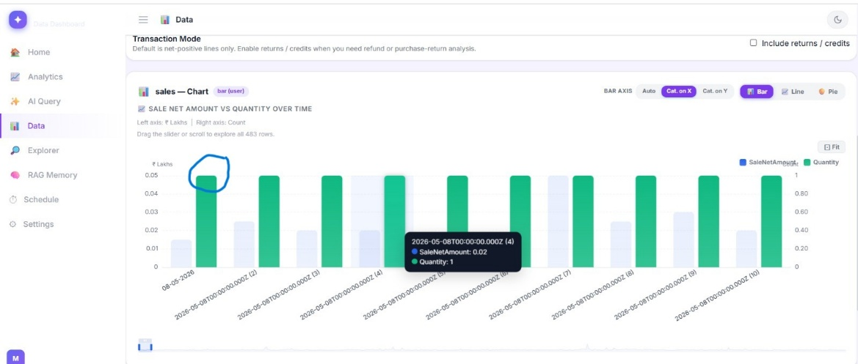

Home page is giving irrelevant details , which are actually don’t require in Dash Board , instead Sales figure , No of Bills generated , Quantity sold etc should be there

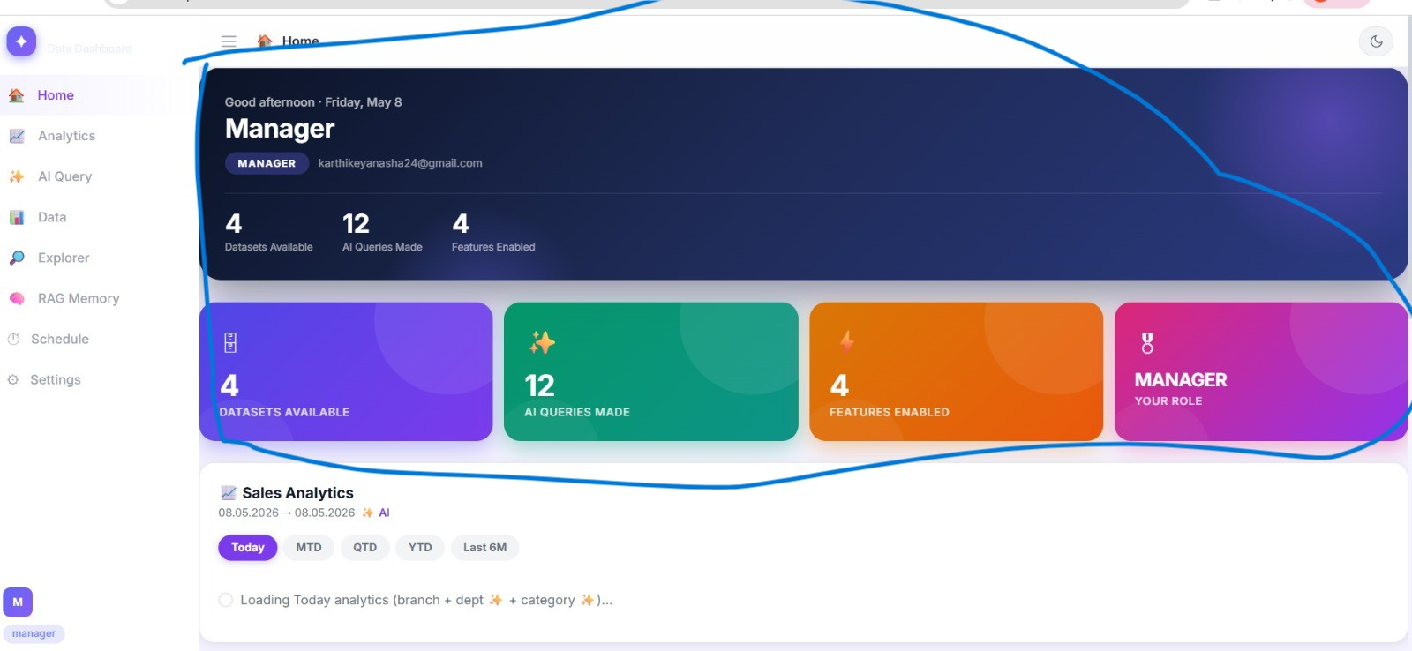

Other than this below points also observed
When we are seeing todays Sales - other than box its appearing in left frame also but same is not happening in case of MTD . QTD , YTD and last 6 months sales
In MTD - Instead of single bar , it should be day wise sales
In QTD / YTS / Last 6 months sales it should be showing month wise sale bar
Further there should be comparison of there should be comparison of Last Year Same period in all Days / MTD / YTD / QTD etc this will make data more understandable and useful
As discussed during call also , Bar Charts should have labels to understand the
numbers

